Computer Networks
ASSIGNMENT 2
Name | S. Sarah Khan | Register No. | 1965260116
Submission Date | 04-11-2026 | Course | Computer Networks (CSA0708)
GitHub Repository | https://github.com/Sarah270809/CSA0708-computer-networks | Nature / Duration | Individual / 1 Week
CO2: Configure IP addressing schemes, subnetting and basic routing techniques using a simulation tool, for efficient network design and topology – packet switching, IPv4 addressing, subnetting, distance-vector and link-state routing, multicast, ICMP, IPv6, software-defined networking, network virtualisation and OpenFlow.
Assignment Title: Address, Subnet and Route a Growing Network Correctly (Total Marks – 50)
Nature of Assignment: Individual
Duration: 1 Week
Simulation Tool: Cisco Packet Tracer (with Python 3 for every “Complete the Code” program)
Bloom’s Level Assessed: K5 – Evaluate
Submission Date: 04-11-2026

Q1 – Spot the Invalid Addresses
1. Network, broadcast and host range of each device
Device | Address / prefix | Mask | Network | Broadcast | Usable range (count) | Verdict
Admission PC | 172.16.45.200 /20 | 255.255.240.0 | 172.16.32.0 | 172.16.47.255 | 172.16.32.1 – 172.16.47.254 (4,094) | Valid host. Gateway 172.16.32.1 is inside the subnet.
Lab printer | 10.0.15.255 /21 | 255.255.248.0 | 10.0.8.0 | 10.0.15.255 | 10.0.8.1 – 10.0.15.254 (2,046) | INVALID – TRAP 1: the address equals the broadcast address.
X-ray server | 192.168.4.0 /23 | 255.255.254.0 | 192.168.4.0 | 192.168.5.255 | 192.168.4.1 – 192.168.5.254 (510) | INVALID – TRAP 2: the address equals the network address.
Clinic router | 203.0.113.10 /29 | 255.255.255.248 | 203.0.113.8 | 203.0.113.15 | 203.0.113.9 – 203.0.113.14 (6) | Valid public host.
- Method (block size): /20 → the third octet moves in blocks of 16, so 45 lies in 32–47. /21 → blocks of 8, so 15 lies in 8–15. /23 → blocks of 2, so 4 lies in 4–5. /29 → the fourth octet moves in blocks of 8, so 10 lies in 8–15. Network = first address of the block, broadcast = last, usable hosts = 2ʰ − 2.
- Why the traps are easy to miss: a /21 and a /23 cross the octet boundary, so “.255” and “.0” look like ordinary hosts. 10.0.15.255 looks like a broadcast only when the block 8–15 is worked out, and 192.168.4.0 is a normal-looking address but is the first address of a /23. Never judge validity from the last octet alone.
- “Run out of addresses”: a /29 has only 8 − 2 = 6 usable addresses (one is the router), but the clinic has 18 devices – hence the NAT inquiry below.
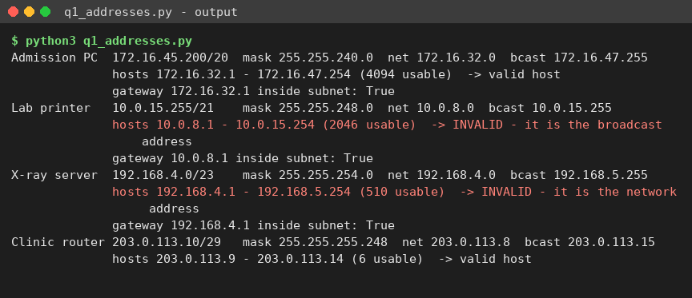

2. Inquiry – NAT with two PCs using source port 50000
PC | Inside local (private) | Inside global (after NAT) | Outside host
PC-1 | 192.168.1.11 : 50000 | 203.0.113.10 : 50000 | 198.51.100.20 : 443
PC-2 | 192.168.1.12 : 50000 | 203.0.113.10 : 50001 | 198.51.100.20 : 443
- The router (NAT overload / PAT) keys each entry on the public address and port it allocates, not on the PC’s own port. PC-2’s source port 50000 is already in use on 203.0.113.10, so the router rewrites it to the next free port (50001). The two entries are different and both work at the same time.
- Return traffic: a reply to 203.0.113.10:50000 is rewritten to 192.168.1.11:50000, and a reply to 203.0.113.10:50001 to 192.168.1.12:50000. Each public address offers about 64,000 ports, so even one address can serve all 18 devices; 6 usable addresses give roughly 380,000 translations.
Datagram switching vs virtual circuits
- Why packets of one file arrive out of order (datagram): every packet is routed independently by a table look-up. If two equal-cost paths exist (for example 20 ms and 30 ms) or the route changes mid-transfer, packet 2 can take the slower path and arrive after packet 3. TCP restores the order with sequence numbers.
Feature | Datagram (IP) | Virtual circuit (ATM, Frame Relay, MPLS LSP)
Set-up | None – send immediately | Call set-up first (about one round trip of delay)
Header | Full destination address (IPv4 header 20 B) | Short circuit identifier (a few bytes)
Path | Each packet may take a different path | One fixed path for the whole call
Order | May arrive out of order | Always in order
Failure | Routes around the failure automatically | Circuit breaks; it must be set up again
Switch state | No per-flow state | One table entry per circuit
Quality of service | Hard to guarantee | Bandwidth and delay can be reserved
Alternative Concept Analysis – a public /27 instead of NAT behind a /29
Measure | NAT behind the /29 | Public /27 (no NAT)
Public addresses needed | 1 (router) – 6 usable in the /29 are enough | 18 devices + router = 19; a /28 has only 14 usable, so a /27 (30 usable) is the smallest block
Address block size / cost | 8 addresses | 32 addresses = 4× the block, so about 4× the leasing cost
Exposure to the internet | Inbound connections blocked by default; devices hidden | Every device is directly reachable – needs a firewall, patching and ACLs on every host
Application problems | Breaks end-to-end addressing, inbound servers need port-forwarding, protocols that carry IP addresses in the payload (active FTP, SIP/VoIP, IPsec AH) need helpers, port exhaustion, no per-device address in logs | None of these – true end-to-end connectivity, simple servers, VoIP and VPN work, each device is traceable
Verdict | Cheaper and safer by default – suitable for a clinic that only browses and uses cloud systems | Justified only if the clinic hosts inbound services; then add a stateful firewall

Q2 – Subnet a Campus That Keeps Growing
1. Design with equal-size subnets (192.168.10.0/24, four subnets)
Four subnets need 2 extra bits, so every subnet is a /26 (255.255.255.192) with 64 − 2 = 62 hosts.
Subnet | Network / prefix | Mask | First host | Last host | Broadcast | Needed | Result
Labs | 192.168.10.0 /26 | 255.255.255.192 | .1 | .62 | .63 | 100 | FAILS – 38 hosts short
Staff | 192.168.10.64 /26 | 255.255.255.192 | .65 | .126 | .127 | 50 | Fits (12 wasted)
Library | 192.168.10.128 /26 | 255.255.255.192 | .129 | .190 | .191 | 25 | Fits (37 wasted)
WAN link | 192.168.10.192 /26 | 255.255.255.192 | .193 | .254 | .255 | 2 | Fits (60 wasted)
- Equal-size subnets cannot work here: a /25 would hold the 100 laboratory hosts but the /24 would give only two subnets, and a /26 gives four subnets but the laboratories do not fit. The point-to-point link wastes 60 addresses.
2. Design with VLSM (largest first)
Subnet | Hosts + 2 | Block | Network / prefix | Mask | First host | Last host | Broadcast
Labs | 102 | 128 | 192.168.10.0 /25 | 255.255.255.128 | 192.168.10.1 | 192.168.10.126 | 192.168.10.127
Staff | 52 | 64 | 192.168.10.128 /26 | 255.255.255.192 | 192.168.10.129 | 192.168.10.190 | 192.168.10.191
Library | 27 | 32 | 192.168.10.192 /27 | 255.255.255.224 | 192.168.10.193 | 192.168.10.222 | 192.168.10.223
WAN link | 4 | 4 | 192.168.10.224 /30 | 255.255.255.252 | 192.168.10.225 | 192.168.10.226 | 192.168.10.227
- Block = the smallest power of two ≥ hosts + 2; prefix = 32 − log₂(block). Allocated 228 of 256 addresses; the next free address is 192.168.10.228 (28 addresses left).
3. The trap – a 60-host hostel six months later
- 60 hosts + 2 = 62, so the hostel needs a /26 block of 64 addresses that starts on a multiple of 64 (.0, .64, .128 or .192). All four are taken. The free space is only 192.168.10.228/30 + .232/29 + .240/28 = 28 addresses, and its largest aligned block is a /28 (14 hosts). It cannot be fitted without renumbering.
- Total demand is now 128 + 64 + 64 + 32 + 4 = 292 addresses, which is more than the 256 in a /24 – so even a complete renumbering inside this /24 is impossible.
- Smallest change that works: give the hostel a second block, 192.168.11.0/26, and advertise 192.168.10.0/23 (the /24 plus the next /24) as one summary. No existing subnet is renumbered.
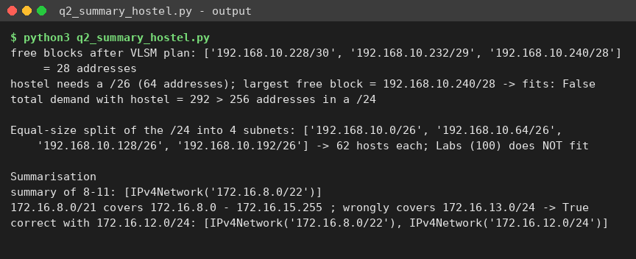
4. Route summarisation
Network | 3rd octet (binary)
172.16.8.0/24 | 0000 1000
172.16.9.0/24 | 0000 1001
172.16.10.0/24 | 0000 1010
172.16.11.0/24 | 0000 1011
- The first 6 bits of the third octet (000010) are common, so the prefix is 16 + 6 = 22: the single summary is 172.16.8.0/22 (covers 172.16.8.0 – 172.16.11.255).
- What goes wrong with 172.16.8.0/21: a /21 covers 172.16.8.0 – 172.16.15.255, i.e. eight /24s. Only 8–12 belong to the campus, so the router now advertises 172.16.13.0, .14.0 and .15.0 that it does not own. Traffic for those networks (which may belong to another site) is pulled to this router and dropped or looped, and the real owner is blocked by the less-specific route. Correct fix: advertise 172.16.8.0/22 and 172.16.12.0/24 separately (or reserve 13–15 for this campus first).
Complete the Code – TODO 1
# TODO 1 (completed)
block = 1 << math.ceil(math.log2(hosts + 2))
prefix = 32 - int(math.log2(block))
ipaddress.ip_network(f"{to_ip(addr)}/{prefix}") # raises ValueError if misaligned
print(f"{name:9s}{to_ip(addr)}/{prefix} hosts {to_ip(addr+1)} - {to_ip(addr+block-2)} bcast {to_ip(addr+block-1)}")
addr += block
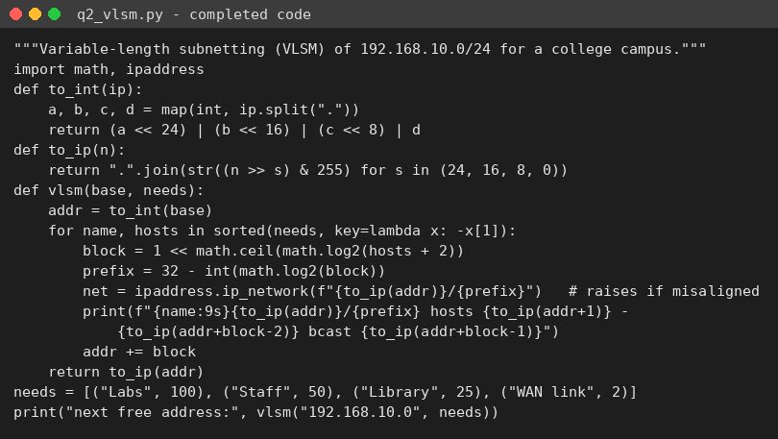
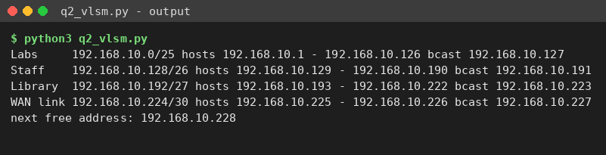

Packet Tracer verification (router CAMPUS-R1)
interface GigabitEthernet0/0
ip address 192.168.10.1 255.255.255.128 ! Labs
interface GigabitEthernet0/1
ip address 192.168.10.129 255.255.255.192 ! Staff
interface GigabitEthernet0/2
ip address 192.168.10.193 255.255.255.224 ! Library
interface Serial0/0/0
ip address 192.168.10.225 255.255.255.252 ! WAN link
clock rate 64000
! hostel attempt (rejected by IOS – overlaps Library/WAN):
interface GigabitEthernet0/3
ip address 192.168.10.229 255.255.255.192

Alternative Concept Analysis – allocating the smallest subnet first
- Starting with the WAN link: 192.168.10.0/30; the next free address is .4, so the Library /27 is placed at 192.168.10.4/27 – but a /27 must start on a multiple of 32. Its real network is 192.168.10.0/27 and it overlaps the WAN link. Staff (.36/26) and Labs (.100/25) are misaligned in the same way (their real networks are .0/26 and .0/25).
- Forcing every block onto its own boundary repairs the overlap but wastes space: WAN .0/30, Library .32/27, Staff .64/26, Labs .128/25 leaves the 28 addresses .4 – .31 unusable and fragmented, so the plan has no contiguous room at all.
- Why VLSM assigns largest first: block sizes are powers of two and every block must start at a multiple of its own size. After the largest block, the running address is a multiple of every smaller size, so each following block is automatically aligned and no gaps appear.
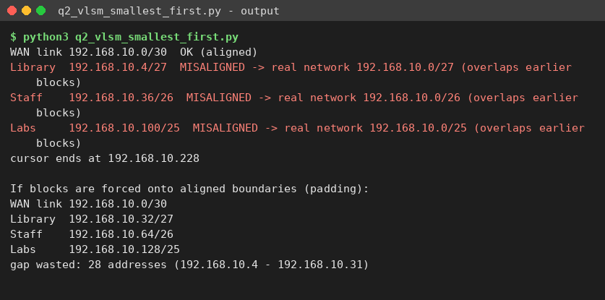

Q3 – Which Way Will the Packet Go?
1. Next hop for each destination
Destination | Matching routes | Chosen (longest prefix) | Next hop
10.1.2.200 | /8, /16, /24, /25, default | 10.1.2.128/25 (covers .128–.255) | 192.0.2.13
10.1.2.100 | /8, /16, /24, default | 10.1.2.0/24 (.100 is outside the /25) | 192.0.2.9
10.1.9.9 | /8, /16, default | 10.1.0.0/16 | 192.0.2.5
10.7.7.7 | /8, default | 10.0.0.0/8 | 192.0.2.1
8.8.8.8 | default only | 0.0.0.0/0 | 198.51.100.1
- Rule used – longest-prefix match: of all routes whose network contains the destination, the router chooses the one with the longest prefix (most specific). The order of the entries does not matter, and the default route 0.0.0.0/0 is used only when nothing else matches.
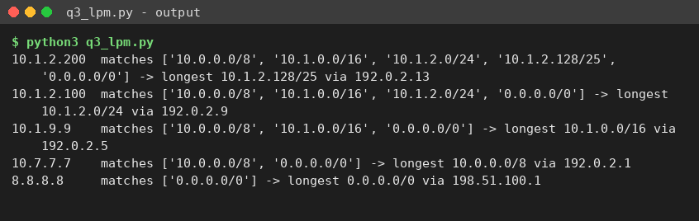
2. Complete the Code – TODO 1 and TODO 2 (R1)
enable
configure terminal
hostname R1
interface GigabitEthernet0/0
ip address 192.168.10.1 255.255.255.0
no shutdown
! TODO 1 (completed)
interface Serial0/0/0
ip address 10.0.0.1 255.255.255.252
clock rate 64000
no shutdown
exit
! TODO 2 (completed)
ip route 192.168.20.0 255.255.255.0 10.0.0.2
end
write memory
show ip route
R2 (reverse route):
hostname R2
interface GigabitEthernet0/0
ip address 192.168.20.1 255.255.255.0
no shutdown
interface Serial0/0/0
ip address 10.0.0.2 255.255.255.252 ! DCE clock is on R1 only
no shutdown
exit
ip route 192.168.10.0 255.255.255.0 10.0.0.1
- Expected result: show ip route on R1 lists S 192.168.20.0/24 [1/0] via 10.0.0.2, and a main-campus PC can ping a city-campus PC.
- Removing the clock rate on the DCE end: with no clocking the serial line cannot synchronise, so the interface shows “up, line protocol is down”; the static route is withdrawn from the routing table (its next hop is no longer reachable) and pings fail with “Destination host unreachable”. Re-entering clock rate 64000 restores the link.

3. Backup link with a floating static route (administrative distance 200)
Add a second serial link 10.0.1.0/30 (R1 S0/0/1 = 10.0.1.1, R2 S0/0/1 = 10.0.1.2) and a backup route with a higher distance than the main route (static = 1):
! R1
ip route 192.168.20.0 255.255.255.0 10.0.0.2 ! main, AD 1
ip route 192.168.20.0 255.255.255.0 10.0.1.2 200 ! floating backup, AD 200
! R2
ip route 192.168.10.0 255.255.255.0 10.0.0.1
ip route 192.168.10.0 255.255.255.0 10.0.1.1 200

Alternative Concept Analysis – OSPF instead of static routes
router ospf 1
network 192.168.10.0 0.0.0.255 area 0
network 10.0.0.0 0.0.0.3 area 0
network 10.0.1.0 0.0.0.3 area 0
Campuses (one LAN each) | Static routes (main only / with floating backup) | OSPF (lines in total)
2 campuses, main + backup link | 2 / 4 lines | 8 lines (router ospf + 3 network lines on each router)
5 campuses in a ring (each router: LAN + 2 links) | 4 routes per router = 20 / 40 lines (two routes for every remote LAN) | 20 lines (4 per router, independent of the number of remote LANs)
- Static routing is cheaper for 2 campuses, but its lines grow with the square of the number of sites; OSPF grows only with the number of local interfaces, so it wins from about 3 campuses upward.
- Recovery (typical defaults): a floating static route reacts at once when the local interface goes down (about a second), but it never notices a failure beyond the next hop while the link stays up – traffic is black-holed until someone intervenes. OSPF detects a silent failure after the dead interval (40 s with default hello 10 s) and then recomputes in about 1–2 s; with an interface-down event it reconverges in a few seconds, and fast hellos can cut detection below a second.

Q4 – Watch Distance-Vector Routing Count to Infinity
1. Round-by-round distance tables (links A–B 2, A–C 7, B–C 3, B–D 8, C–D 1, D–E 4)
Each cell is the vector of distances to (A, B, C, D, E); ∞ = no route known yet.
Round | A | B | C | D | E
0 (neighbours only) | 0 2 7 ∞ ∞ | 2 0 3 8 ∞ | 7 3 0 1 ∞ | ∞ 8 1 0 4 | ∞ ∞ ∞ 4 0
1 | 0 2 5 8 ∞ | 2 0 3 4 12 | 5 3 0 1 5 | 8 4 1 0 4 | ∞ 12 5 4 0
2 | 0 2 5 6 12 | 2 0 3 4 8 | 5 3 0 1 5 | 6 4 1 0 4 | 12 8 5 4 0
3 | 0 2 5 6 10 | 2 0 3 4 8 | 5 3 0 1 5 | 6 4 1 0 4 | 10 8 5 4 0
4 (no change) | 0 2 5 6 10 | 2 0 3 4 8 | 5 3 0 1 5 | 6 4 1 0 4 | 10 8 5 4 0
- Converged after 4 rounds (rounds 1–3 change something; round 4 changes nothing, which proves convergence). Bold = value changed in that round.
- Why A’s best route to C is not the direct link: the direct link costs 7, but A → B → C costs 2 + 3 = 5, so the next hop for C is B. In the same way A reaches D via B (cost 6) and E via B (cost 10).
Complete the Code – TODO 1
# TODO 1 (completed)
if link[u, n] + old[n][dest] < table[u][dest]:
table[u][dest] = link[u, n] + old[n][dest]
changed = True
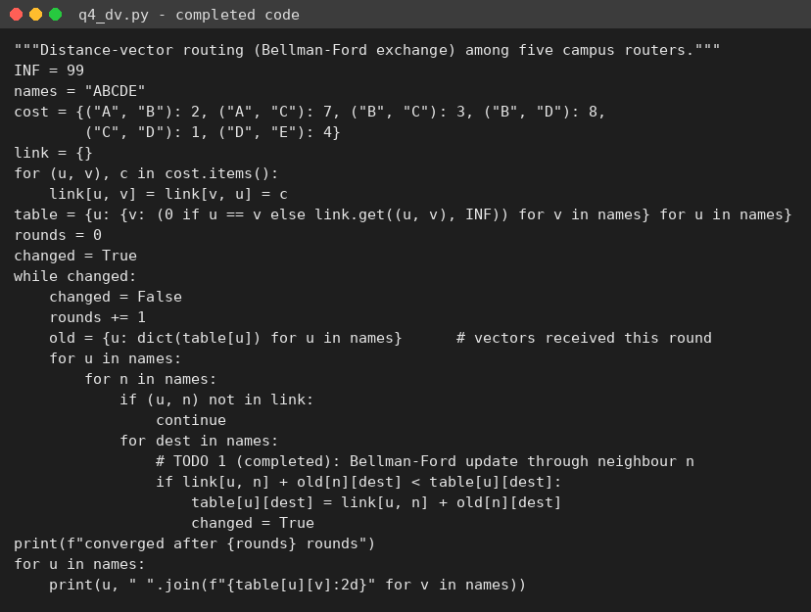

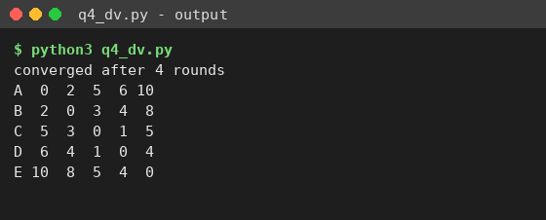
After the C–D link fails (cost set to 99) – q4_dv_fail.py:
Router | to A | to B | to C | to D | to E
A | 0 | 2 | 5 | 10 | 14
B | 2 | 0 | 3 | 8 | 12
C | 5 | 3 | 0 | 11 | 15
D | 10 | 8 | 11 | 0 | 4
E | 14 | 12 | 15 | 4 | 0
- Converged after 3 rounds. Every path to D and E now goes B → D (cost 8); for example C → D rises from 1 to 11 (C → B → D = 3 + 8) and A → D from 6 to 10. Bold = values that changed from the earlier table.
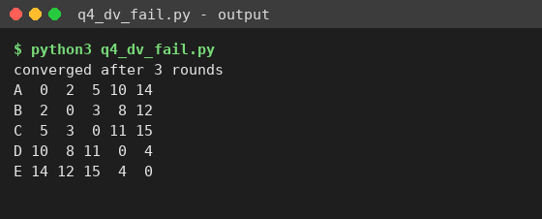
2. Count to infinity on X – Y – Z (cost 1 each), link Y–Z fails
Round | X → Z (via Y) | Y → Z | What happens
0 (before) | 2 | 1 | Normal: Y reaches Z directly, X through Y
1 | 2 | 3 | Y loses Z, hears X’s old “Z = 2” and believes X has a path: 2 + 1 = 3 (through X!)
2 | 4 | 3 | X hears Y’s “Z = 3” and updates to 4
3 | 4 | 5 | Y hears X’s 4 and updates to 5
4 … 14 | 6, 8, 10, 12, 14, 16 | 5, 7, 9, 11, 13, 15 | Distances climb by 2 per pair of rounds (a routing loop X ↔ Y)
15 | 16 | 16 | RIP infinity = 16 reached – Z finally declared unreachable after 15 rounds
- Split horizon with poison reverse: X learned Z from Y, so X advertises “Z = ∞ (16)” back to Y instead of 2. Y therefore never believes X has a path to Z: Y sets Z = ∞ in round 1 and X follows in round 2 – the loop is prevented and Z is unreachable after 2 rounds instead of 15.
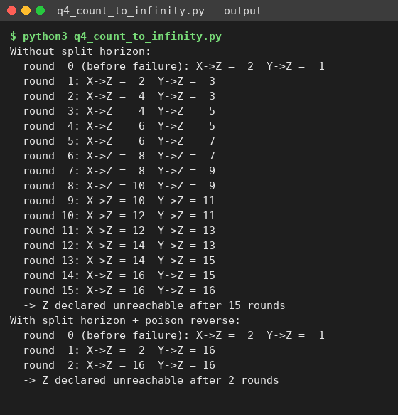
3. RIP in Packet Tracer
router rip
version 2
no auto-summary
network 192.168.1.0
network 10.0.12.0
passive-interface GigabitEthernet0/0
! verify
show ip route rip
show ip protocols
debug ip rip
- Test: ping across the network, shut down one link, watch show ip route rip. RIP default timers: update 30 s, invalid 180 s, hold-down 180 s, flush 240 s. When the interface itself goes down, a triggered update with metric 16 is sent at once; a silent failure is only noticed after the 180 s invalid timer – the slow convergence that makes RIP unsuitable for large networks.

Alternative Concept Analysis – link-state routing on the same network
Measure (C–D fails) | Distance vector | Link-state
Messages | Every router sends its vector to each neighbour every round: 2 × 6 links = 12 messages per round × 3 rounds = 36 vector messages (5 entries each) | C and D each flood one LSA over the 5 surviving links: 2L − (N − 1) = 10 − 4 = 6 transmissions each → 12 LSA messages (one link entry each)
Rounds until all routes are correct | 3 rounds | 3 flooding hops (C’s LSA reaches E over C–B–D–E), then every router runs Dijkstra locally – no further messages
Count to infinity | Possible (needs split horizon, poison reverse, hold-down) | Not possible – every router holds the same complete map
Cost | Light CPU and memory | Full topology database and Dijkstra at every router
.

Q5 – Why Does OSPF Treat 1 Gbps and 10 Gbps the Same?
1. OSPF cost = reference bandwidth ÷ link bandwidth (minimum 1)
Link | Cost, reference 100 Mbps (default) | Cost, reference 100,000 Mbps (100 Gbps)
10 Mbps | 100 ÷ 10 = 10 | 100,000 ÷ 10 = 10,000
100 Mbps | 100 ÷ 100 = 1 | 100,000 ÷ 100 = 1,000
1 Gbps | 100 ÷ 1,000 = 0.1 → rounded up to 1 | 100,000 ÷ 1,000 = 100
10 Gbps | 100 ÷ 10,000 = 0.01 → rounded up to 1 | 100,000 ÷ 10,000 = 10
- The problem: with the default 100 Mbps reference, 100 Mbps, 1 Gbps and 10 Gbps links all cost 1. OSPF cannot see that the 10 Gbps path is ten times faster; when hop counts are equal the paths tie and traffic is shared (ECMP) or the 1 Gbps path is used, so the slower link congests.
- New reference bandwidth: 100,000 Mbps (auto-cost reference-bandwidth 100000). It makes 10 Gbps cost 10 and leaves room for 100 Gbps links (cost 1). It must be configured identically on every router, otherwise they calculate different costs.
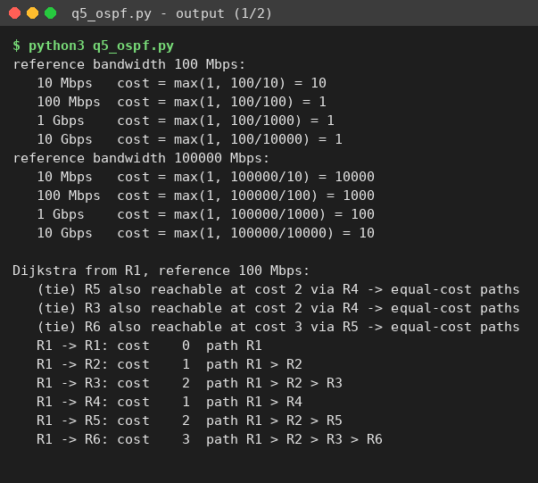
2. Dijkstra by hand from R1 (6-router ISP of my design)
Link |  |  | Speed | Cost (ref 100 Gbps)
R1–R2, R2–R3, R3–R6 |  |  | 10 Gbps | 10
R1–R4, R4–R5, R5–R6, R2–R5 |  |  | 1 Gbps | 100
R3–R4 |  |  | 100 Mbps | 1,000
Step | Router settled (cost) | Updates (distance to R2 / R3 / R4 / R5 / R6)
0 | R1 (0) | R2 = 10, R4 = 100; others ∞
1 | R2 (10) | R3 = 20, R5 = 10 + 100 = 110
2 | R3 (20) | R6 = 20 + 10 = 30 (R4 via R3 = 1,020 – worse than 100)
3 | R6 (30) | R5 via R6 = 130 – worse than 110, no change
4 | R4 (100) | R5 via R4 = 200 – worse, no change
5 | R5 (110) | All routers settled
- Shortest-path tree from R1: R1 → R2 (10), R2 → R3 (20), R3 → R6 (30, all-10 Gbps path), R2 → R5 (110), R1 → R4 (100). With the default reference, R1 → R6 via the 10 Gbps path (cost 3) ties with R1–R4–R5–R6 over 1 Gbps links (cost 3); now it is 30 against 300, so only the 10 Gbps path is used.
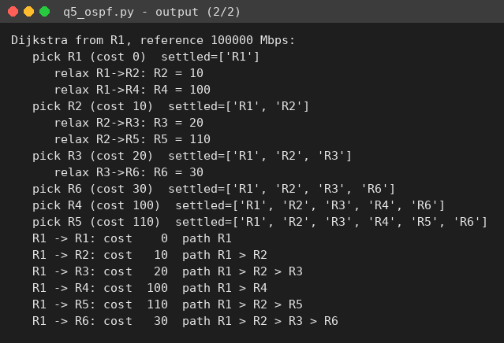
3. Packet Tracer configuration
interface GigabitEthernet0/0
bandwidth 10000000 ! emulate 10 Gbps (kbit/s)
interface GigabitEthernet0/1
bandwidth 1000000 ! 1 Gbps
router ospf 1
router-id 1.1.1.1
auto-cost reference-bandwidth 100000
network 10.0.12.0 0.0.0.3 area 0
! verify
show ip ospf interface brief ! cost 10 on 10 Gbps, 100 on 1 Gbps links
show ip route ospf ! R6 LAN [110/30] via the 10 Gbps path

4. One OSPF area or several?
- Decision: a single backbone area 0 for this 6-router design. The link-state database is tiny, Dijkstra takes microseconds, and one area has no ABRs, no inter-area suboptimal routing and the simplest operation.
- Move to several areas (area 0 as the backbone plus one area per city cluster) once the provider grows beyond roughly 30–50 routers or unstable links cause frequent SPF runs: LSAs and SPF are then confined to one area, and the ABRs can summarise each city’s prefixes. The trade-off is more design effort and every area must attach to area 0.
Alternative Concept Analysis – EIGRP or IS-IS
EIGRP metric = 256 × (10⁷ ÷ minimum bandwidth in kbit/s + sum of delays in tens of µs). Assumed paths of 3 links with the usual 10 µs delay on each Gigabit/10-Gigabit interface (3 × 1 = 3 units).
Protocol | Path of 1 Gbps links | Path of 10 Gbps links | Distinguishes them without a change?
OSPF, default reference (100 Mbps) | 1 + 1 + 1 = 3 | 1 + 1 + 1 = 3 | No – tie
OSPF, reference 100 Gbps | 100 × 3 = 300 | 10 × 3 = 30 | Yes, after the change
EIGRP (classic metric) | 256 × (10⁷ ÷ 10⁶ + 3) = 256 × 13 = 3,328 | 256 × (10⁷ ÷ 10⁷ + 3) = 256 × 4 = 1,024 | Yes – bandwidth is part of the metric
IS-IS (default metric 10 per link on common implementations) | 10 × 3 = 30 | 10 × 3 = 30 | No – needs manual metrics
- Decision: EIGRP avoids the problem with no change, but it is Cisco-originated and its classic bandwidth term saturates at 10 Gbps. OSPF with a one-line reference-bandwidth change is multi-vendor and scales to 100 Gbps, so it remains the better choice for a state ISP unless the whole network is Cisco.

Q6 – IPv6, ICMP, Multicast and SDN in a Smart City
1. IPv6 shortening and EUI-64
- 2001:0db8:0000:0000:0000:ff00:0042:8329 → remove leading zeros in each group, then replace the longest run of all-zero groups by “::” → 2001:db8::ff00:42:8329.
- MAC 00:1A:2B:3C:4D:5E: split it in two (00:1A:2B | 3C:4D:5E), insert FF:FE in the middle and flip the universal/local bit of the first byte (0x00 → 0x02): interface identifier 021A:2BFF:FE3C:4D5E, so the link-local address is fe80::21a:2bff:fe3c:4d5e.
2. How traceroute uses ICMP Time Exceeded
- traceroute sends probes with TTL = 1; the first router decrements the TTL to 0, discards the packet and returns ICMP Time Exceeded (type 11) whose source address is that router. The next probe has TTL = 2 and exposes the second router, and so on. When a probe finally reaches the destination, the destination answers (ICMP echo reply or port unreachable) and the trace ends. The round-trip time of each reply gives the per-hop delay. (IPv6 uses the Hop Limit field and ICMPv6 type 3.)
3. Multicast MAC for 239.1.2.3
- The multicast MAC is 01:00:5E followed by the lower 23 bits of the group address: 239.1.2.3 → lower 23 bits = 1.2.3 → 01:00:5E:01:02:03. (32 IPv4 groups share each MAC because 5 bits are dropped.)
- One stream, several control rooms: each control room joins group 239.1.2.3 with IGMP and the routers build a distribution tree (PIM). The camera sends one copy; routers and switches copy the packet only where the paths to receivers split. Example: a 4 Mbps stream to 5 control rooms costs the camera 4 Mbps with multicast but 5 × 4 = 20 Mbps with unicast.
4. OpenFlow rules and the SDN decision
Packet | Rules matched | Winning rule (highest priority) | Action
HTTP to 10.5.1.1 (TCP 80) | priority 200 (dst 10.5.0.0/16) and priority 100 (TCP 80) | Priority 200 | Forward out port 3 – not sent to the controller
SSH to 10.6.1.1 (TCP 22) | only priority 0 | Priority 0 (table-miss) | Dropped
- Judgement – adopt SDN, in stages. Benefits: one central view and policy for 2 million sensors and the camera network, routing changes in minutes by software, easy traffic engineering and automation. Risks: the controller is a single point of failure and a security target (use a clustered controller), flow-table size limits (TCAM), and “send to controller” rules can overload it. Recommended: pilot SDN on the camera/sensor segments with a redundant controller cluster, keep an ordinary routing protocol (OSPF) as a fallback underlay, then extend to the whole city.
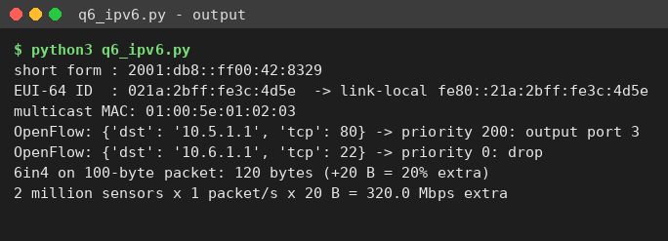
Alternative Concept Analysis – IPv6 only, dual-stack or 6in4 tunnelling
Approach | Advantages | Disadvantages
IPv6 only | Simplest network, huge address space (2 million sensors need ≥ 2²¹ IPv4 addresses, an impractical public block) | Old IPv4 devices and services unreachable without NAT64/DNS64
Dual-stack | Works with both worlds, no translation, no tunnel overhead | Two sets of configuration and security policy; more memory
6in4 tunnel (IPv6 inside IPv4, protocol 41) | Crosses IPv4-only links without upgrading them | +20 B per packet, lower MTU (1,480 B), harder troubleshooting, tunnel end-points become bottlenecks
- Tunnel overhead: a 100-byte sensor packet becomes 100 + 20 = 120 bytes (+20 %). If each of the 2 million sensors sends one packet per second, the tunnel adds 2,000,000 × 20 B × 8 = 320 Mbps of pure overhead.
- Decision: start with dual-stack in the core and edge so existing IPv4 equipment keeps working, deploy all new sensor networks IPv6-only (with NAT64 where needed), and use 6in4 tunnels only as a temporary bridge across IPv4-only links.

Q7 – Find the Weak Point, Redesign and Validate
Network chosen: the engineering-college campus of Q2 (192.168.10.0/24 with VLSM), which fails when the hostel is added. The redesign is an addressing and summarisation change – no extra equipment is added.
- Identify the limitation
- The VLSM plan is correct for today’s needs, but it uses 228 of 256 addresses and leaves 28 addresses in three small pieces (192.168.10.228/30, .232/29, .240/28). The largest aligned block is a /28 (14 hosts), while the hostel needs a /26 (64 addresses): the hostel allocation fails (q7 test 1).
- The root cause is not the VLSM method but the fixed single /24 with no reserved growth space: total demand is 128 + 64 + 64 + 32 + 4 = 292 addresses > 256, so no rearrangement or renumbering inside the /24 can succeed. The four separate prefixes also need four routes upstream.
B. Design objective
# | Measurable objective | Original
1 | Place the 60-host hostel with 0 existing subnets renumbered | Fails
2 | Keep ≥ 40 % of the address space free after the hostel for growth | 11 % free (28 of 256)
3 | Advertise the whole campus upstream as 1 summary route | 4 specific routes
C. The revised network
Keep every existing subnet exactly as it is and extend the campus block from 192.168.10.0/24 to 192.168.10.0/23 (512 addresses). The hostel gets 192.168.11.0/26; 192.168.11.64/26 and 192.168.11.128/25 are reserved for growth. The campus router advertises 192.168.10.0/23 as one summary and holds a discard route (Null0) for the summary.
- New trade-offs: a second /24 of private space is consumed (free, but it must be reserved in the college’s plan); the summary also covers 220 unused addresses, so traffic to unassigned addresses must be discarded by the Null0 route to avoid loops; the hostel needs one more router interface (or a VLAN sub-interface on the existing one).
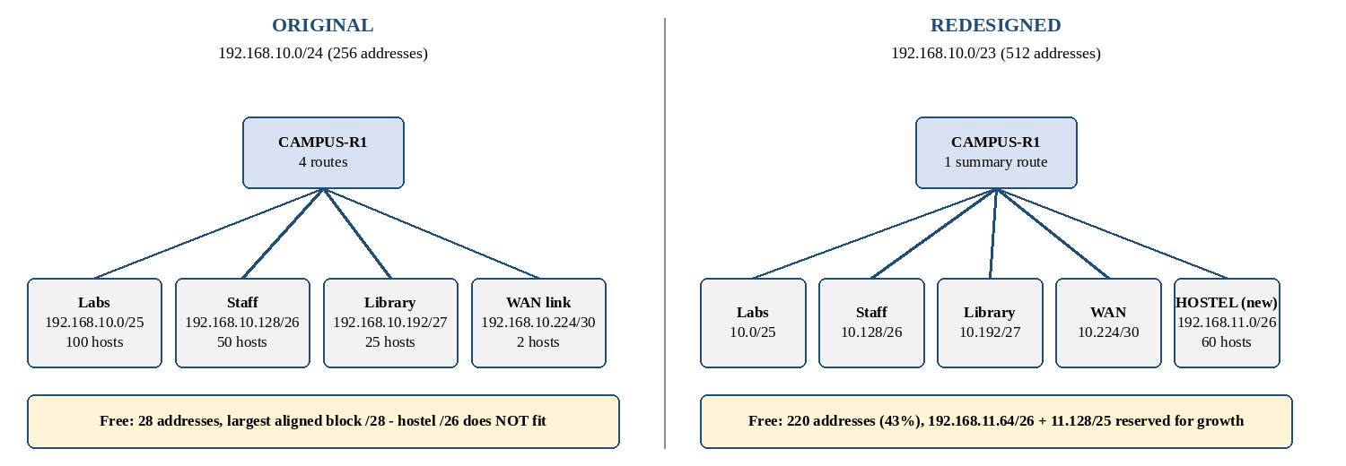

Subnet | Network / prefix | Mask | Usable hosts | Gateway (router) | Status
Labs | 192.168.10.0 /25 | 255.255.255.128 | 192.168.10.1 – .126 | 192.168.10.1 | Unchanged
Staff | 192.168.10.128 /26 | 255.255.255.192 | .129 – .190 | 192.168.10.129 | Unchanged
Library | 192.168.10.192 /27 | 255.255.255.224 | .193 – .222 | 192.168.10.193 | Unchanged
WAN link | 192.168.10.224 /30 | 255.255.255.252 | .225 – .226 | 192.168.10.225 | Unchanged
Hostel | 192.168.11.0 /26 | 255.255.255.192 | 192.168.11.1 – .62 | 192.168.11.1 | New
Reserved | 192.168.11.64 /26 and 192.168.11.128 /25 | — | 190 addresses | — | Growth
interface GigabitEthernet0/3
description Hostel
ip address 192.168.11.1 255.255.255.192
no shutdown
ip route 192.168.10.0 255.255.254.0 Null0 ! discard unused part of the summary
! upstream (city) router
ip route 192.168.10.0 255.255.254.0 192.168.10.226
D. Prediction before implementing
The hostel allocation will succeed with 0 renumbered subnets; free space will rise from 28 addresses (11 %) to 220 addresses (43 %) after the hostel is added; and the upstream router will need 1 summary route instead of 4 specific routes.
E. Implement and validate – Original → Redesigned
Test | Original (/24) | Redesigned (/23)
1. Allocate 60-host hostel | FAILED – no aligned /26 free | Allocated 192.168.11.0/26
2. Overlaps between subnets | None | None
3. Largest free block | 192.168.10.240/28 | 192.168.11.128/25
4. Free addresses | 28 of 256 (11 %) | 220 of 512 (43 %)
5. Subnets renumbered | 0 | 0
6. Summary route | 192.168.10.0/24 (replaces 4 routes) | 192.168.10.0/23 (replaces 5 routes)
7. Summary covers unused space | 28 addresses | 220 addresses (Null0 discard)
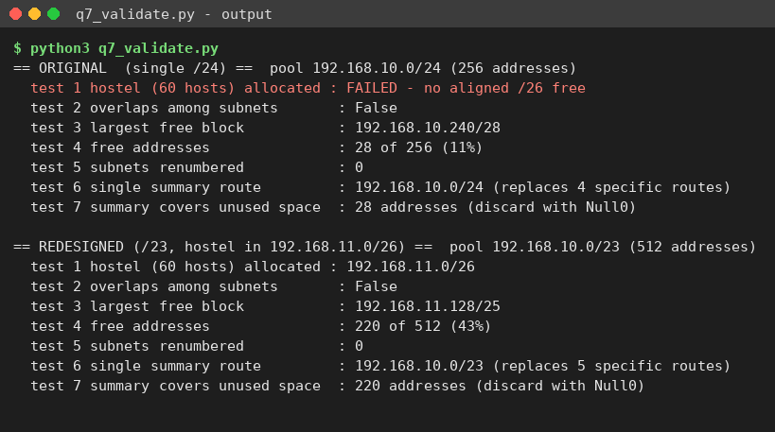

Packet Tracer tests (same for both versions): ping from a Labs PC to the Staff PC, the Library PC, the WAN-side router and (redesigned only) the Hostel PC; show ip route on the upstream router; attempt to configure the hostel interface.

F. Defend the final design
- Objective achieved: hostel placed with 0 renumbered subnets (objective 1), 43 % free ≥ 40 % (objective 2), and one summary route (objective 3) – all three measured by q7_validate.py.
- New costs: a second /24 of private space is reserved; the summary includes 220 unused addresses, so a Null0 discard route is mandatory; one extra router interface; the hostel is a separate broadcast domain.
- Where the original is still preferable: if the hostel is never built, the single /24 is simpler and uses 89 % of its space; and if the college only has one /24 (for example a public block from the provider), the redesign is impossible and the hostel would need its own provider block or NAT behind a separate network.

